Effects of Two GnRH-based Recombinant Vaccine Candidates on Pig Fertility
Roberto Basulto Baker*, Gerardo Guillén Nieto**, Lesvia Calzada Aguilera*, Jesús Junco Barranco*, Nelson Izquierdo Pérez***, Osvaldo Reyes Acosta**, Hilda Garay Pérez**, Ricardo Bringas Pérez**, Eulogio Pimentel Vázquez*, José A. Bertot***, Rafael Avilés***, María Dolores Castro Santana*, Eddy Bover Fuentes*, Franklin Fuentes Aguilar*
* Center of Genetic Engineering and Biotechnology (CIGB), Camagüey, Cuba
** Center of Genetic Engineering and Biotechnology (CIGB), Havana, Cuba
*** Faulty of Agricultural Sciences Ignacio Agramonte Loynaz University of, Camagüey, Cuba
roberto.basulto@cigb.edu.cu

Abstract
This paper describes for the first time the generation of the K88ab-GnRH hybrid fimbria, the fusion of N. meningitidis P64k protein (P64k-GnRH), and its evaluation as vaccine candidates to control fertility in mammals. Twenty hybrid male pigs were randomly distributed in four groups: placebos and immunized with K88ab-GnRH, P64k-GnRH and a GnRH analogue (GnRHm1), linked to a tetanus toxoid (TT) T-helper epitope (positive control), respectively. The pigs were immunized at 9-10 weeks of age, using a two-dose scheme, and were sacrificed sixteen weeks later. K88ab-GnRH, P64k-GnRH, and GnRHm1-TT induced higher, similar, and lower testosterone levels in the serum, compared to the placebo, respectively. In the K88ab-GnRH group, the pigs underwent a reduction in testicle size and weight (P < 0.01), and a reduction in the weight of epididymes compared to the placebo; none of them was able to ejaculate. In the P64k-GnRH group, the pigs had a reduction in testicle weight (P < 0.05), and only one of them was able to ejaculate. The testicles of the pigs immunized with K88ab-GnRH and P64k-GnRH showed structural and functional damage; spermatogenesis was also affected. The accessory sexual glands of the P64k-GnRH group were normal, in contrast to K88ab-GnRH, where interstitial fibrosis was observed. The damage caused by K88ab-GnRH and P64k-GnRH in the target organs evaluated were in all cases lower than the affectations caused by the GnRHm1-TT peptide.
Key words: GnRH, K88ab P64k, immunocastration, carrier protein

Introduction
The gonadotropin releasing hormone (GnRH) is a structurally conserved molecule which is critical in the control of mammal reproduction (Millar, Pawson, Morgan, Rissman, and Lu (2008). Immunocastration based on an immune response against GnRH is a more appropriate, less traumatic alternative to surgical castration, which can also be reverted (Andersson, Brunius, Zamaratskaia, and Lundström, 2012). However, GnRH is a hapten and self-antigen, and several strategies must be implemented to generate antibodies against the molecule, including the generation of one or multiple copies of GnRH analogue peptides, which cannot be recognized as produced by the immune system. These peptides must be coupled to carrier proteins, like tetanus toxoid, diphtheria toxoid, or their synthetic T-helper epitopes (Fuentes et al., 2017). Another strategy implemented is the fusion of GnRH to the P fimbria, and its expression in E.coli K-12 (Van der Zee et al., 1995); or the expression of the Dichelobacter nodosus fimbriae in Pseudomonas aeruginosa (Mott and Reilly, 1994).
Vaccination against GnRH could be an alternative for farm animals to reduce aggressiveness and prevent pregnancy, sexuality, and changes in the scent and color of the meat of non-castrated swine, equines, bovines, and ovine-caprines (Stevens et al., 2005; Janett, Stump, Burger, and Thun, 2009; Han et al., 2015; Mancini, Menozzi, and Filippo, 2017; and Yamsakul et al., 2017). In pets and wildlife species, a vaccine against GnRH might prevent overpopulation and undesired sexual behavior (Basulto, et al., 2003; Levy, Friary, Miller, Tucker, and Fagerstone, 2011).
This paper describes the cloning of the gene codifying for the major K88ab fimbrial subunit in mammal GnRH for the first time, as well as the gene for dehydrogenase dihydrolipoamide (IpdA) or P64k protein from the N. meningitidis bacterium. Additionally, this paper evaluates the role of prepuberal male pigs as animal models for a vaccine candidate to achieve immunocastration of mammals.

Materials and methods
Bacterial strains, plasmids, and culture media
E.coli K-12 strains and culture media supplemented with ampicillin (100 μg/mL) were used for plasmid selection. Plasmids pK203 (Fig. 1A), containing structural genes for biosynthesis and K88ab fimbrial expression were used (Bakker et al., 1992). They were inserted at the Hind III site of the pUC19 and pM-6 vectors (Silva et al., 1992), which comprised the gene codifying for IpdA or the P64k protein of N. meningitidis (Guillén et al., 1998), under the tryptophan enhancer cloned at the pUC-18 vector, generated at the Centers of Genetic Engineering and Biotechnology in Havana and Camagüey.
Design and synthesis of the GnRHm1-TT peptide
The GnRHm1-TT peptide (C-QHWSYPLRPGGGQYIKANSKFIGITEL-NH2), which includes the GnRH modified variant from mammals (Bringas, Basulto, Reyes, and de la Fuente, 1998), was achieved at the CIGB in Havana, through solid phase synthesis, using Fmoc/tBu (Fields and Noble, 1990).
DNA cloning
Plasmid pK203 was digested with restriction endonuclease Eco-RI, and religated, using ligase DNA T4 to reduce its size by removing the Eco RI (2) Eco RI (3) fragment (Fig. 1A). The resulting pK333 plasmid, contains the faeA-H genes from genetic determinant K88ab (Fig. 1A). Digestion of pK333 with Bss HII (Fig. 1A) enabled the replacement of the hypervariable region of the faeG fimbrial subunit (Fig. 1B), with the 70-base-pair synthetic adapter that codifies for GnRH (Fig. 1C), and generated the pK365 plasmid. The pM6 was digested with Mlu I to introduce the oligonucleotides codifying for GnRH (5´-CGCGCAGCACTGGTCCTATGGACTGCGCCCTGGAGA-3´ and 3´-GTCGTGACCAGGATACCTGACGCGGGACCTCTGCGC-5´) in the lpdA gene. The plasmid achieved was named p64k-GnRH.
Expression and purification of the K88ab-GnRH fimbria and the P64k-GnRH recombinant protein
The precipitate containing E.coli cells transformed with pK365 was resuspended in saline phosphate buffer solution (PBS) 1X (137 mM NaCl; 2.7 mM KCl; 10 mM Na2HPO4; 1.8 mM KH2PO4; pH 7.2); then it was incubated for 20 min at 60 ºC, and the supernatant was removed carefully. The p64k-GnRH-transformed bacteria were ruptured by ultrasonic homogenizer (Labsonic U, B. Braun, Germany). The sediment in 1X PBS was precipitated with 40 and 60% ammonia sulfate; then it was centrifuged, resuspended, and dialyzed against 1X PBS, for 48 h. In both cases, the target proteins were preserved at-20 ºC until used.
Immunological detection of the K88ab fimbria and the P64k protein
K88ab was detected through ELISA, using the CBC-K88a1 monoclonal antibody (Castro et al., 2004). The expression of P64k was detected by colony immunoidentification and Western-blot, using the anti P64k monoclonal antibody (AcM) 114-HRP (Guillén et al., 1998).
Protein determination
The determination of total proteins was made through the Lowry technique, and quantification of the K88ab-GnRH and P64k-GnRH proteins was made by protein electrophoresis (SDS-PAGE) and optic densitometry.
Animals
A total number of twenty hybrid male pigs were distributed at random in four experimental groups. The pigs were lodged in suitable facilities, and managed according to the manual for swine breeding in Cuba.
Immunization of pigs against GnRH
Each vaccine contained 0.4 mg of each antigen. In all cases, the proteins were resuspended in 1X PBS and emulsified in Freund´s complete adjuvant (FCA) (1:1) a few minutes prior to vaccination. The 9-10 week old pigs, weighing 11.5 kg, were immunized intramuscularly on the side of the neck, with 2 mL of the vaccine, and a second dose was administered after 8 weeks, with the same composition, but in Freund´s incomplete adjuvant (FIA). One group of animals was vaccinated with 1X PBS and FCA or FIA only, and was used as placebo. Another group was vaccinated with GnRHm1-TT and was the positive control. The other two groups were immunized with K88ab-GnRH and P64k-GnRH, respectively.
In vivo and post mortem evaluations
Starting with the first immunization, and every 4 weeks, the testicles were measured with a caliper gauge. For serum collection and further determination of testosterone levels, blood samples were taken in the 16th week by injection through the retro-orbital sinus (Fuentes et al., 2017). The unconditional reflexes during mating (approaching, foreplay, erection of penis, mounting and hugging, attempts to introduce the penis in the vagina, friction, ejaculation, and normal position) were also monitored. These reflexes were evaluated as good (1) when they were clearly manifested; and bad (0) when they were not produced, at least in one of the three evaluations made for each reflex. The stimulation of boars was made with a natural estrus sow. The pigs were sacrificed at the end of the 16th week, following the Cuban standards. The epididymes, prostates, seminal vesicles, and bulbo-urethral glands were removed and weighed. The testicles were measured and weighed. To perform the histological examination, samples of transversal and sagital sections were taken. Staining was made by the hematoxillin eosin method.
Statistical analysis
One way ANOVA and Tukey´s multiple comparison test were run in GraphPad Prism 6, for Windows, version 6.01. Values of P < 0.05 were considered statistically significant.

Results and discussion
The insertion of GnRH in pK365 reduced the production of fimbrial K88ab by 81.3%, compared to pK333. However, it did not affect the production of the P64k protein in pM6 (data not shown).
In all the pigs, after the first insemination, their testicles continued to grow as in the placebo. Only when the immunization scheme was completed, the testicles of the pigs vaccinated against GnRH were observed to grow smaller.
The pigs immunized with K88ab-GnRH showed a mean testosterone value of 16.71 ± 8.53 nmol/L, compared to the placebo (8.91 ± 3.71 nmol/L). The P64k-GnRH and GnRHm1-TT groups showed testosterone levels of 8.47 ± 5.23 nmol/L and 1.18 ± 0.92 nmol/L, similar and lower in relation to the placebo, respectively.
The reduction of testosterone serum levels must have induced a significant decrease in size and weight of testicles and accessory glands of the animals immunized against GnRH. The K88ab-GnRH group showed a higher mean testosterone value in relation to the placebo. In this group, three pigs with values of >10.40 nmol/L were observed to approach; two of them were observed to mount, have erection, and penetrate the sow´s vagina (Table 1). The remaining two groups showed < 7.50 nmol/L, coinciding with the two animals that did not develop unconditional mating reflexes (Table 1). Two of the pigs immunized with P64k-GnRH had erection and mounted the sow, and one of them ejaculated. In the GnRHm1-TT group, four pigs showed testosterone values of ≤0.95 nmol/L; three of them showed ≤0.07 nmol/L, which was below the castration level for this animal species (0.4 nmol/L), and therefore were immunocastrated. Only one pig showed 4.79 nmol/L, coinciding with the only pig in this experimental group that developed all the primary reflexes of mating (Table 1).
In the K88ab-GnRH group, three pigs were able to approach the sow and were aroused; two of them had erection and mounted the sow, but neither ejaculated. In the GnRHm1-TT group, only one pig showed all the unconditional reflexes of mating (Table 1). One ping in the P64k-GnRH group and another in the GnRHm1-TT group, were aggressive in the presence of estrus sows, but did not approach or show arousal. The pigs immunized against GnRH underwent a decrease in unconditional reflexes related to mating, which was most remarkable in the GnRHm1-TT group, according to the weight and size of testicles and the testosterone levels observed. The animals with testicular atrophy could not develop the primary reflexes of mating.
K88ab-GnRH significantly decreased the length and weight of testicles, and the weight of epididymes. P64K-GnRH only reduced (P<0.05) the weight of testicles. GnRHm1-TT produced a significant reduction in width, length, and weight of testicles, and the weight of epididymes, seminal vesicles, bulbo-urethral glands, and prostates, when all the animals were compared to the placebo (Table 1, Fig. 2). No significant differences were observed between the K88ab-GnRH and P64K-GnRH groups (P>0.95). In turn, GnRHm1-TT significantly reduced testicle length, compared to K88ab-GnRH and P64K-GnRH, respectively; and the width of testicles, compared to P64K-GnRH.
The testicles of pigs immunized with K88ab-GnRH underwent partial (1/5) and complete (2/5) elimination of the functional parenchyma of the seminiferous tubules (Fig. 3A). The least affected samples showed few nemasperms (3/5). Cases of slight fibrosis were observed in the interlobular testicular septa, which may have caused a decrease in the diameter of the seminiferous tubules. In epididymes, minimum (2/5), and moderate (1/5) presence, as well as absence (2/5) of spermatozoa was observed; interstitial fibrosis was produced in accessory sexual glands. Pigs immunized with P64K-GnRH underwent a reduction in the diameter of seminiferous tubules; most of them (3/5) contained sertoli cells only, and a minimal (1/5), moderate (1/5), and absence (3/5) of spermatozoa in epididymes and normal sexual glands. The testicles in the GnRHm1-TT group underwent a critical reduction in the diameter of the seminiferous tubules and atrophy, which started with vacuolar degeneration of spermatids and continued with the spermatocytes, until achieving complete elimination of the functional parenchyma of the seminiferous tubules (4/5). In only one pig, tubules with spermatogonia were occasionally observed. No sperm secretion was observed in epididymes (4/5). Fibrosis was observed in the seminal vesicles; the bulbo-urethral glands showed thickening of the trabeculae, and fibrosis; and the prostates showed abundant fibrotic tissue with reduction of the secretory tabular glands. Several types of germinal cells and spermatozoa were observed in the seminiferous tubules of the 3 pigs in the placebo group (Fig. 3B), including apparent spermatogenesis and histologically normal sexual glands. Neither of the experimental groups underwent histological distortions in the leydig cells.
The aim of this study was to evaluate the possible use of the K88ab fimbria and P64k protein as GnRH carriers, to control fertility in domesticated animals and pets.
A single fimbriated K88 bacterium contains several hundreds of FaeG copies on its surface. This subunit is used as carrier of bacterium N. gonorrhoeae derived peptides from the foot and mouth disease and the human deficiency virus (Bakker, van Zijderveld, van der Veen, Oudega, and de Graaf, 1990), and influenza and somatostatine-derived peptides (Thiry, Clippe, Scarcez, and Petre, 1989). The insertion of GnRH in K88ab may have caused a change in the conformational structure of the fimbria, which might decrease the capacity of the monoclonal antibody to recognize K88ab.
The high molecular weight and immunogenicity of P64k made it the proper carrier protein of covalently bound weak immunogens (González et al., 2000), or chimeric constructs (González et al., 1997; Guillén et al., 1997). The insertion of GnRH into the p64k-GnRH plasmid did not affect the expression levels of the P64k protein of N. meningitidis in E.coli.
The possible pharmacological effects caused by these vaccine candidates were evaluated in prepuberal pigs. The analysis of these results included the insertion of the GnRH codifying sequence of mammals into both genetic constructs, without modification of their amino acidic composition. Van der Zee et al. (1995), and Mott and Reilly (1994) were able to fuse GnRH to P fimbriae and D. nodosus, respectively. So far, however, neither has evaluated the pharmacological effects of this hybrid fimbriae on pigs.
The P64k-GnRH and K88ab-GnRH groups underwent a reduction of 40.4 and 52.7% in mean testicle weight, respectively, in comparison to the placebo group (Fig. 2), mainly due to a decrease in the diameter of the seminiferous tubules (Fig. 3A). These results were better than the results achieved by Zeng et al. (2002). In turn, the reduction of testicle weight with K88ab-GnRH was similar to the values achieved in pigs using the standard vaccination scheme with Improvac® (Andersson et al., 2012). As expected, GnRHm1-TT underwent a greater reduction in testicle weight (73.9%) (Fig. 2), comparable to the results reported by Einarsson et al. (2011) and Yamsakul et al. (2017).
The neutralization of the endogenous action of GnRH (Junco et al. 2008; Thompson, 2000), requires direct binding to a sufficient amount of neutralizing antibodies. It was not possible to set up an ELISA to determine anti GnRH antibodies in pigs; however, the response of anti GnRH antibodies was demonstrated in other animal species, using the same vaccine candidate (Basulto et al., 2003; Junco et al., 2007). Considering the analogy of these results, a similar phenomenon might occur in pigs.
The result achieved for GnRH in carrier proteins K88ab and P64k was unexpected, since the large number of T-helper epitopes would lead to a more functional response than using a single T-helper epitope from tetanus toxoid. Possibly, these proteins also contained B epitopes that may have diverted the immune response or created steric effects that hindered an adequate antigenic presentation. It may also be possible because GnRH did not have the amino acidic change used in the GnRHm1-TT combination.

Conclusions
The K88ab-GnRH and P64k-GnRH vaccine candidates caused structural and functional transformations compatible with infertility in the testicles and epididymes of prepuberal pigs. However, the biological effects caused by these candidates, which included natural GnRH from mammals, were less homogeneous and effective than with the GnRHm1-TT peptide, including the modified variant of the hormone.

References
Andersson, K.; Brunius, C.; Zamaratskaia, G. y Lundström, K. (2012). Early Vaccination with Improvac®: Effects on Performance and Behaviour of Male Pigs. Animal 6(1), 87-95.
Bakker, D.; Van Zijderveld, F. G.; Van Der Veen, S.; Oudega, B. y De Graaf, F. K. (1990). K88 Fimbriae as Carriers of Heterologous Antigenic Determinants. Microb Pathogen, 8 (1), 343-352.
Bakker, D.; Willemsen, P. T. J.; Willems, R. H.; Huisman, T. T.; Mooi, F. R.; Oudega, B. et al. (1992). Identification of Minor Fimbrial Subunits Involves in Biosynthesis of K88 Fimbriae. J Bacteriol, 174(20), 6350-6358.
Basulto, R.; Milanés, C.; Rojas, A.; Fuentes, F.; Izquierdo, N.; Bertot, J. et al. (2003). Efectos de la inmunocastración contra GnRH sobre la estructura y función testicular en perros adultos. Biotecnol Apl, 20(1), 20-24.
Bringas, R.; Basulto, R.; Reyes, O. y De La Fuente, J. (1998). Vaccine for the Reversible Immunocastration of Mammals. Patent Cooperation Treaty (PCT) WO 98/27111.
Castro, M. D.; Campal, Ana; León, L.; Miranda, A.; Junco, J.; Arteaga, N. et al. (2004). Inmunodominancia del epítope “a” de las fimbrias K88. Rev Prod Anim, 16(1), 59-66.
Einarson, S.; Brunius, C.; Wallgren, M.; LUNDSTROM, K.; Anderson, K.; Zamaratskaia, G. et al. (2011). Effects of Early Vaccination wiht Improvac® on the Development and Function of Reproductive Organs of Male Pigs. Anim Reprod Sci, 127(1-2), 50-55.
Fields, G. B. y Noble, R. L. (1990). Solid Phase Peptide Synthesis Utilizing 9-Fluorenylmethoxycarbonyl Amino Acids. Int J Pept Protein Res, 35(3), 161-214.
Fuentes, F.; Junco, J.; Calzada, L.; Bover, E.; Serradelo, J. A.; Hernández, E.; Pimentel, E.; Basulto, R.; Reyes, O.; Garay, H. y Guillén, G. (2017). The Influence of Different Peptide Combinations to Increase the Immunogenicity of the Gonadotrophin Releasing Hormone Vaccine for Prostate Cancer Treatment. J Experiment Therap Oncol, 12 (1), 87-94.
González, G.; Álvarez, A.; Caballero, E.; Viña, L.; Guillén, G. y Silva, R. (2000). P64k Meningococcal Protein as Immunological Carrier for weak Immunogens. Scand J Immunol, 52(1), 113-116.
González, G.; Pardo, O.; SÁNCHEZ, B.; García, J.; Beausoleil, I.; Marinello, P. et al. (1997). Induction of Immune Recognition of Self-Epidermal Growth Factor II: Characterization of the Antibody Response and the Use of a Fusion Protein. Vaccine Res, 6(4), 91-100.
Guillén, G.; Álvarez, A.; Silva, R.; Morera, V.; González, S.; Musacchio, A. et al. (1998). Expression in Escherichia coli of the lpdA Gene, Protein Sequence Analysis, and Immunological Characterisation of the P64K Protein from Neisseria meningitidis. Biotechnol Appl Biochem, 27(1), 189-196.
Guillén, G.; Duarte, C.; Álvarez, A.; et al. (1997). System for the Expression of Heterologous Antigens as Fusion Proteins. PCT Patent WO 97/26359.
Han, X.; Gu, L.; Xia, C.; Feng, J.; Cao, X.; Du, X. et al. (2015). Effect of Immunization against GnRH on Hypothalamic and Testicular Function in Rams. Theriogenol, 83(4), 642-649.
Janett, F.; Stump, R.; Burger, D. y Thun, R. (2009). Suppression of Testicular Function and Sexual Behavior by Vaccination against GnRH (Equity) in the Adult Stallion. Anim Reprod Sci, 115(1-4), 88-102.
Junco, J.; Basulto, R.; Fuentes, F.; Bover, E.; Castro, M. D.; Reyes, O. et al. (2008). Induction of Androgenic Ablation and Inhibition of Prostate Hormone-Sensitive Tumors by Immunization with the GnRHm1-TT Synthetic Peptide Adjuvated in VSSP. Biotecnol Apl, 25(2), 174-176.
Junco, J.; Peschke, P.; Zuna, I.; Ehemann, V.; Fuentes, F.; Bover, E. et al. (2007). Immunotherapy of Prostate Cancer in a Murine Model using a Novel GnRH Based Vaccine Candidate. Vaccine, 25 (1), 8460-8468.
Levy, J. K.; Friary, J. A.; Miller, L. A.; Tucker, S. J. y Fagerstone, K. A. (2011). Long-Term Fertility Control in Female Cats with GonaCon™, a GnRH Immunocontraceptive. Theriogenol, 76 (1), 1517-1525.
Mancini, M. C.; Menozzi, D. y Filippo, A. (2017). Immunocastration: Economic implications for the pork supply chain and consumer perception. An assessment of existing research. Livestock Sci., 203 (1), 10-20.
Millar, R. P.; Pawson, A. J.; Morgan, K.; Rissman, E. F. y Lu, Z. L. (2008). Diversity of Actions of GnRHs Mediated by Ligand-Induced Selective Signalling. Front Neuroendocrin, 29(1), 17-35.
Mott, M. R. y Reilly, W. (1994). Double Immunogold Labelling Demonstrating Expression of Recombinant Genes for Production of an Anti-Fertility Vaccine. Micron, 25(6), 539-545.
Silva, R.; Selman, M.; Guillén, G.; Herrera, L.; Fernández, J.; Novoa, L. et al. (1992). Nucleotide Sequence Coding for an Outer Membrane Protein from Neisseria meningitides and use of Said Protein in Vaccine Preparations. European Patent Office, Publication number EP 0474313 A2.
Stevens, J. D.; Sosa, J. M.; Deavila, D. M.; Oatley, J. M.; Bertrand, K. P.; Gaskins, C. T. et al. (2005). Luteinizing Hormone-Releasing Hormone Fusion Protein Vaccines Block Estrous Cycle Activity in Beef Heifers. J. Anim. Sci., 83(1), 152-159.
Thiry, G.; Clippe, A.; Scarcez, T. y Petre, J. (1989). Cloning of DNA Sequences Encoding Foreing Peptides and their Expression in the K88 pili. Appl Environmental Microbiol, 55(4), 984-993.
Thompson, D. L. (2000). Immunization against GnRH in male species (comparative aspects). Anim. Reprod. Sci., 60 (1), 459-469.
Van Der Zee, A.; Noordegraaf, C. V.; Van Den Bosch, H.; Gielen, J.; Bergmans, H.; Hoekstra, W. et al. (1995). P-fimbriae of Escherichia coli as Carriers for Gonadotropin Releasing Hormone: Development of a Recombinant Contraceptive Vaccine. Vaccine, 13(1), 753-758.
Yamsakul, P.; Patchanee, P.; Yano, T.; Boonma, T.; Somkert, C. y Sathanawongs, A. (2017). Gonadotropin-Releasing Hormone Immunization and Castration in Male Pigs: Effects on Growth, Hormonal Levels, Antibody Titer Response, Testicular Function, Back Fat, and Consumers’ Sensory Perceptions. Korean J. Vet. Res., 57(1), 23-29.
Zeng, X. Y.; Turkstra, J. A.; Meloen, R. H.; Liu, X. Y.; Chen, F. Q.; Schaaper, W. M. et al. (2002). Active Immunization against Gonadotrophin-Releasing Hormone in Chinese Male Pigs: Effects of Dose on Antibody Titer, Hormone Levels and Sexual Development. Anim Reprod Sci, 70(1), 223-233.
.

Received: 3-10-2018
Accepted: 3-16-2018

(A)

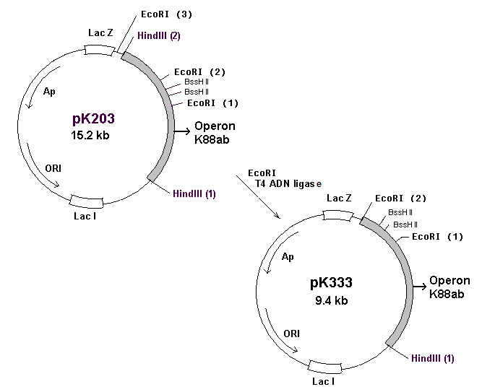

T T T V S G A A L T S
(B) K88ab 5’ – GGT.GGT.TTG.ACG.ACG.ACT.GTT.TCG.GGT.GCT.GCA.CTC.ACG.AGT.GGG.AGT.GCC – 3’
| |
163 173

(C)
Q H W S Y G L R P G
5’ – CGC.GCT.ATC.TTT.TAT.GGT.GGT.TTG.CAG.CAC.TGG.TCC.TAT.GGA.CTG.CGC.CCT.GGA.GGG.AGT.GCC.GCA.GCG.G – 3’
3’ – GA.TAG.AAA.ATA.CCA.CCA.AAC.GTC.GTG.ACC.AGG.ATA.CCT.GAC.GCG.GGA.CCT.CCC.TCA.CGG.CGT.CGC.CGC.GC – 5’

Fig. 1. Genetic map of plasmids pK203 and pK333. ORI, replication origin; Ap ampicillin-resistance gene; lac Z and lac I, genes codifying for β-galactosidase and lactose repressor, respectively; K88ab operon, genetic determinant codifying for the E.coli K88ab fimbria; kb, kilobase (A). Nucleotide sequence and its corresponding amino acid sequence for the hypervariable region (aminoacids 163-174) of the K88ab fimbria (B). Nucleotide sequence of the GnRH corresponding synthetic adapter (C).

(Table 1) Evaluation in prepuberal pigs (n = 5 for each experimental group) of the effect of GnRH immunization on the unconditional reflexes of mating (week 16), and on testicle width and length, at sacrifice
Evaluations | Placebo | P64K-GnRH | K88ab-GnRH | GnRHm1-TT
Unconditional reflexes
of mating
Approaching | 3/5 | 2/5 | 3/5 | 1/5
Erection of penis | 3/5 | 2/5 | 2/5 | 1/5
Mounting and hugging | 3/5 | 2/5 | 2/5 | 1/5
Ejaculation | 2/5 | 1/5 | 0/5 | 1/5
Testicle length¹ (mm) | 93.10 ± 2.92 | 76.00 ± 4.72 | 71.20ª ± 3.18 | 51.90^{b} ± 5.75
Testicle width¹ (mm) | 56.30 ± 2.21 | 47.00 ± 3.28 | 43.90 ± 1.77 | 33.00^{b} ± 4.01
¹ All the values are reported as the means ± M S E. (mean standard error).
ª P < 0.01, ^{b} P < 0.0001, compared to placebo

.
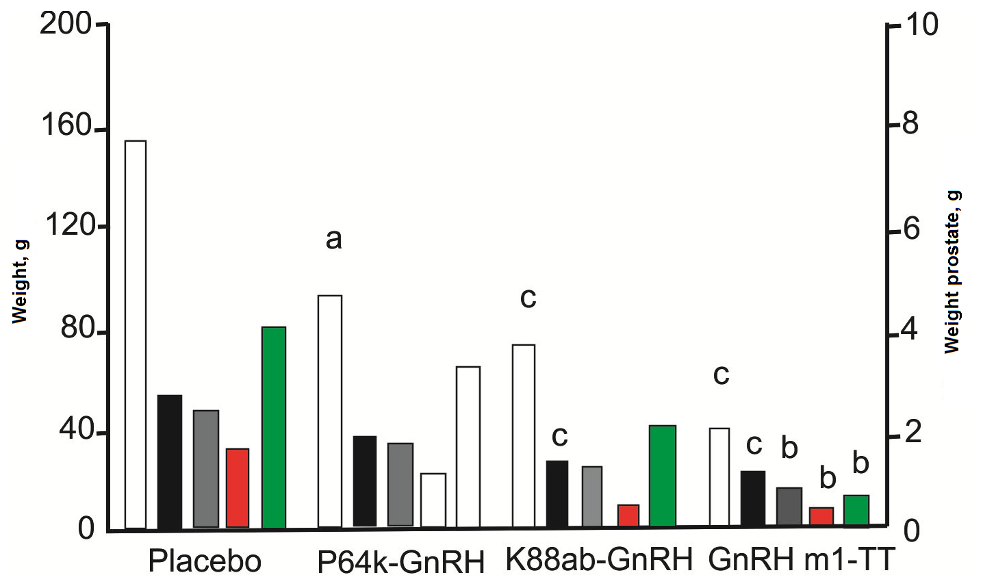
1. All the values correspond to the mean ± M S E. (mean standard error).
a. (P <<0.05)
b. P < 0.01
c. P < 0.001, compared to the placebo.

Fig. 2. Evaluation of prepuberal pigs (n = 5 for each experimental group) of the effect of GnRH immunization on testicle weight (Test.), epididymes (Epid), bulbo-urethral glands (B.U.G.), seminal vesicles (V.S.), and prostates (Prost.)

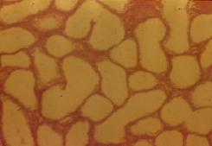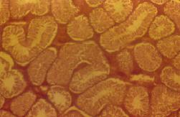
A B
Fig. 3. Transversal section of testicle from a pig immunized with K88ab-GnRH (A), compared to a placebo (GnRH) pig (B). 40x increase).

